**SOLUTION ROADMAP**

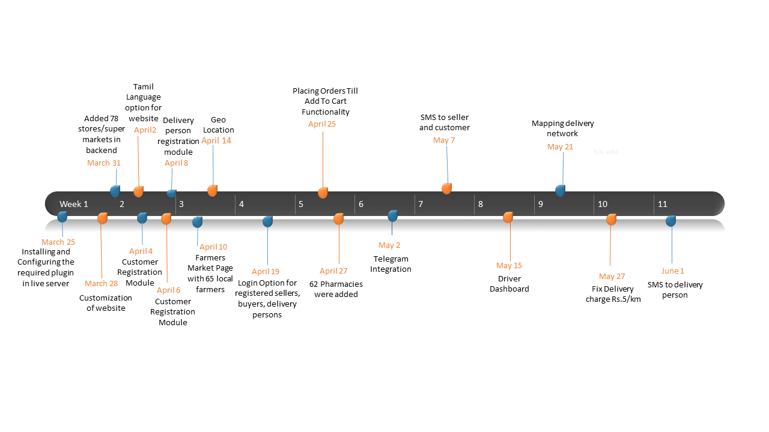

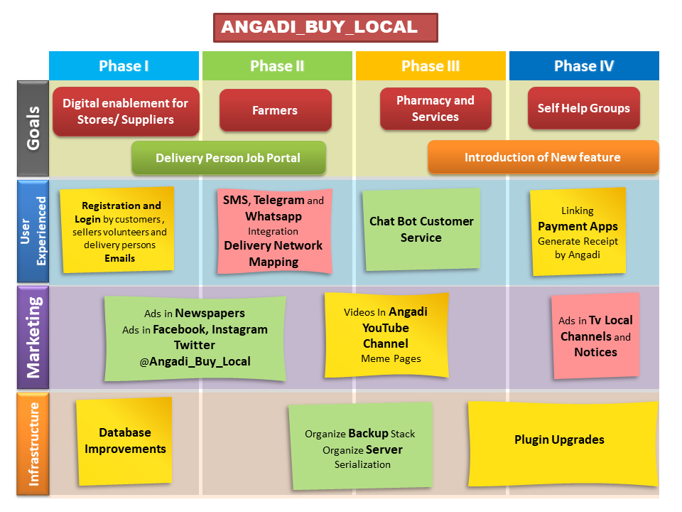

**BUSINESS MODEL**



**FUNDING**

* The Angadi Project is currently being funded under AICTE – UBA scheme by Mrs. Kalpana.R and Mrs. Kavitha Kumar, Pondicherry Engineering College.
* Voluntary and Technical Support of Mr.MK Dhandapani, Director Linkeddots Engineering Solutions, Bangalore.
* Alumni of PEC